BLK2-GT1 Electric Roller (DC 24V) Driver Card User Manual
-  Precautions
- The 0V (negative pole) of the driver card power supply is grounded
- Before powering on, please make sure the positive and negative poles of the driver card power supply are connected correctly.
- Do not use in explosive environments, flammable gas environments, corrosive environments, places exposed to water, or near flammable materials.
- Do not touch the connection terminals of the driver card immediately after turning off the power (within 30 seconds), as residual voltage may cause electric shock.
- When setting up, connecting, running, operating, checking, and troubleshooting, all operations must be performed by qualified personnel.
- Please do not move, set up, connect, check, etc. when the power is on. When operating, be sure to cut off the power before operating.
Environmental requirements: Indoor (no direct sunlight, rain, water droplets, condensation and corrosive gas)
Usage Environment
Main Features
- Constant speed, start and stop, forward and reverse
- Dial speed regulation and IO control
- Acceleration/deceleration time adjustment
- Overvoltage/undervoltage/overcurrent protection
- Multiple LED alarm indicators
Operating ambient temperature | -10-40℃
Operating environment humidity | 10%-90%RH (no frost)

Electrical parameters
Brushless motor for electric roller
 | Numerical | default value | unit
Current | --- | 4.0 | A
Pole pairs | --- | 2 | ---
Maximum speed | 4955 | --- | RPM

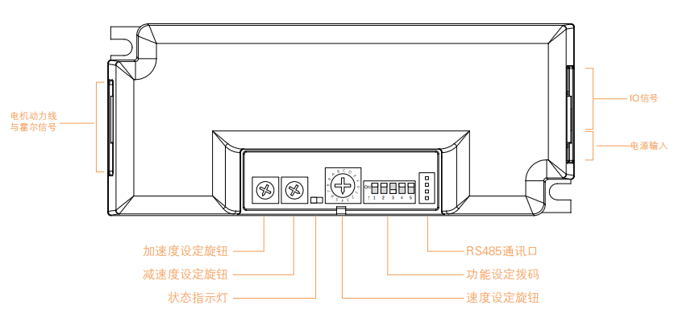Interface Definition

Interface Functio

Interface Function
Features and functions |  |  | Remark
powered by | Voltage | Normal operating voltage 24V±5%
Signal  port | Name (English) | describe
Signal  port | PLS | Speed ​​output signal | 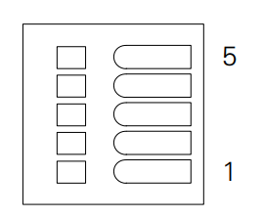
Signal  port | ERR | Alarm output signal
Signal  port | V_IN | Analog input signal
Signal  port | DIR | Direction input signal
Signal  port | RUN | Start input signal

Rotary encoder
Knob position  (Gear) | Motor speed  (RPM) | Speed ​​knob | Knob position  (Gear) | Motor speed  (RPM)
0 | 619 |  | 5 | 3299
1 | 825 |  | 6 | 3741
2 | 1246 |  | 7 | 4121
3 | 1656 |  | 8 | 4563
4 | 2490 |  | 9 | 4955

Acceleration and deceleration potentiometer
VR1-ACC  VR2-DEC | Acceleration and deceleration (milliseconds) | 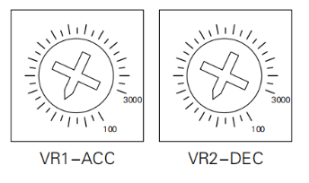
Minimum | 100
Maximum | 300
DIP switch
Dip switch | illustrate | ON | OFF | default
SW1 | Automatic/manual reset switch | Manual reset | Automatic reset | ON
SW2 | Internal/external speed setting selection | external | internal | OFF
SW3 | Motor rotation direction | Reverse direction | Direction is not reversed | OFF
SW4 | Alarm signal output polarity | Output when no alarm | Output when an alarm occurs | OFF
SW5 | Braking method | Servo brake | Electromagnetic brake | OFF
SW6 | Alarm output signal type | PNP output | NPN output | ON

Control mode settings
NPN type connection | PNP type connection
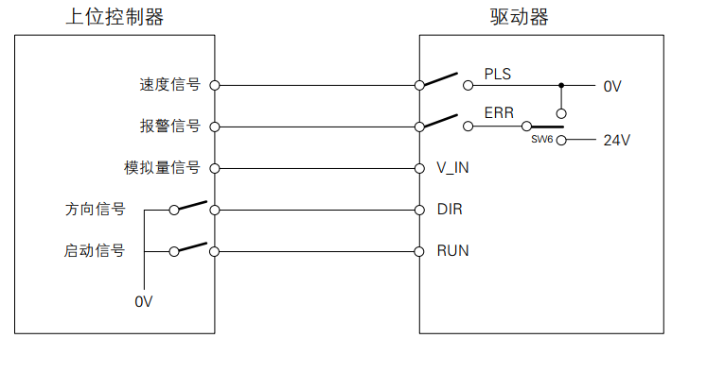 | 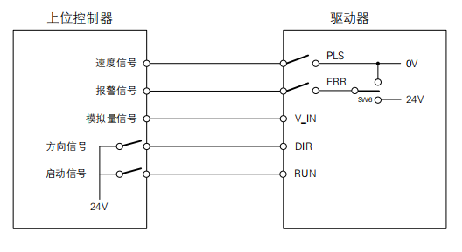

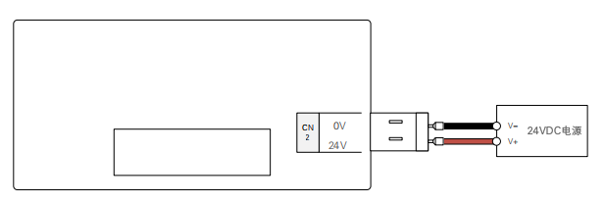Power connection

LED light indication
LED Status | describe | Cause of failure
Green light is always on | Motor enable | ------------------
Red light is on | Motor not enabled | ------------------
Flashing green light | The motor is running | ------------------
1 green 1 red | Motor overspeed | The motor pole pair number does not match or stalls
1 green 2 red | Commutation failure | The motor is stalled or the Hall effect is faulty during the commutation process.
2 green 1 red | Motor stall | External torque is too large
1 green 3 red | Drive temperature is too high | The working environment temperature is too high
1 green 4 red | Driver voltage is too high | The power supply voltage is too high
1 green 5 red | Driver overcurrent | Motor wiring error or MOS short circuit
1 green 6 red | Motor open circuit | The motor power line is not connected properly
2 green 3 red | Internal voltage error | Driver internal circuit failure
2 green 4 red | Driver voltage is too low | The supply voltage is lower than 15VDC
2 green 5 red | Motor overload | External load is too large
2 green 6 red | Hall signal error | Hall signal line is not connected properly
1 green 7 red | Communication Error | The communication line is not connected properly
2 green 7 red | FLASH read/write errors | ------------------

